**Laser & IoT based Integrated Environment with Real-Time Vehicle Accident Prevention Module and Location Tracker**

**Richa saxena1, Mohd. Suhail2, Aman Ruhela3, Himanshu Singh4**

**1Assistant Professor, CS&E Department, MIT, Moradabad**

[**richasaxena2006@gmail.com**](mailto:richasaxena2006@gmail.com)

**2B.Tech 2nd Year, CS&E Department, MIT, Moradabad**

[**mohdsuhail2232@gmail.com**](mailto:mohdsuhail2232@gmail.com)

**3B.Tech 2nd Year, CS&E Department, MIT, Moradabad**

[**amanruhela36@gmail.com**](mailto:amanruhela36@gmail.com)

**4B.Tech 2nd Year, CS&E Department, MIT, Moradabad**

[**himanshuwch@gmail.com**](mailto:himanshuwch@gmail.com)

***ABSTRACT***

*In an IoT world, we have several devices that can be helpful in various sectors. There are many sectors in which accidents occur rapidly. One of the major sectors is road traffic accidents. By using the Microcontroller devices, GPS, MQ-3 alcohol gas sensor, ESP8266 Wi-Fi module, LM35 temperature sensor, Laser beam, or Laser projector, we can establish a system in which the location of the vehicle, driver’s health, alcohol level, pulse & temperature can be monitored. We can monitor these all things remotely from anywhere by using the Internet. For remote access of the Internet by the microcontroller device, we have many Wi-Fi modules, one of the popular Wi-Fi modules is Node MCU ESP8266 to provide the connection to the microcontroller boards. We can also monitor the Humidity of any atmosphere as well as air quality. With the help of this IoT-based monitoring system, we can decrease the number of road- traffic accidents. By establishing a system based on laser projection on road behind the vehicle. we can also decrease the number of road traffic accidents in foggy weather.*

***KEYWORDS***

*IoT, Microcontrollers, Neo 6M GPS Module, MQ-3 Alcohol sensor, IR sensor, Ethernet Shield, ESP8266 Wi-Fi Module, DHT22 Humidity sensor, LM-35 Temperature sensor, Laser Projector, L3G4200D Gyroscope Sensor.*

1. **INTRODUCTION**

According to W.H.O, approximately 1.3 million people die every year in road traffic accidents, there are many factors of these types of accidents i.e.,

high-speed driving, the influence of alcohol and drugs, calling while driving, invisibility due to fog, etc. in the world. By the Times of India article “North India has the greatest number of accident cases due to fog especially in four months, November, December, January, February. The death rate is also high in these accidents as the accident that happened in the fog can be dangerous.

In India, the Ministry of Road Transport and Highways state that 12678 people died in 2018 due to fog-related accident in India. In 2017 this figure is near about 11090, and in 2016 it is 9317. So, this type of accident is increasing day by day in India as well as all over the world. In addition, a proposed system which is very much helpful to avoid this type of accident especially in foggy weather drink and drive cases, etc.

To avoid accidents due to bad weather drinking we are going to implement a system called **“IoT and Laser-Based Driver’s Health & Vehicle Monitoring Systems”.** In this proposed system an IOT based architecture is used. Apart from this, our system will also detect the driver’s alcohol level as well as pulse rate body temperature to monitor the health of the driver remotely, in addition, the location of the vehicle will also be captured by the GPS, GSM modules and to send the data to web servers to see the actual location of the vehicle and further future analysis.

* 1. **IoT (Internet of Things)**

IoT represents the physical objects and machines that can communicate with each other with the help of networks. Networks can be LAN (Local Area Network), WAN (Wide Area Network), Wi-Fi, Bluetooth. In this, we used some type of embedded system sensors, Micro-Controllers, Actuators. If we talk about the physical object every physical thing (i.e., Ceiling Fan, AC, Refrigerators as well as Doors, Windows, Table, etc.) go under this category. As we all know everything has its advantages as well as its drawbacks [1].

IoT is very useful in our day-to-day life. It can make human life easier and do the boring task automatically and very efficiently for example sometimes a person forgot to lock the door of their house and now he is in their office or other workplace but suddenly he needs to lock that door. So, by using IoT architecture and a particular setup he can easily lock their door from anywhere and at any time. But on the other hand, the implementation of these types of IoT setups has major challenges like Data encryption, Big Data analysis, Data Security (Avoid Cyber-Threats), etc. The sensors and as well as actuators generate a large amount of data. Handling and storing these types of data are major challenges. For security purposes, one can use Blockchain technology for data encryption which is generated by the sensors and other types of microcontroller devices. Sensors are the very basic block of IoT it is not wrong if we state that the sensors are the backbone of this technology. Actuators are electro-mechanical devices that are used to convert electrical signals into mechanical movements. It acts like a human hand for the IoT systems to perform actions after receiving the electric signals.

1. **LITERATURE REVIEW**

**2.1. Microcontrollers for IoT**

A micro controller is nothing but a small size of computer which is capable of processing data, memory, and also a programmable circuit [2].

Microcontrollers are a very useful part of IoT as well as other automation factors. According to an analysis, there are more than one hundred IoT devices in the world [6]. After 2014, there is a huge change in the IoT world occurred, the new generation of microcontrollers are introduced with the high-performance and reliability. The 32-bit Microcontrollers come into the IoT world that was a huge change. These microcontrollers are based on RISC (Reduces Instruction Set Computer) ARM cortex-M4-7, etc. These microcontrollers are now capable to share the data over the network and have wireless technology [3].

**2.1.1 Arduino microcontrollers**

Arduino was first introduced by Diecimila in 2007, at the time of its release Arduino has various Atmel AVR. In 2012 first time 32-bit ARM Cortex-M3 processor was launched in the Arduino family. Arduino is an open-source microprocessor board and can be used by anyone for any type of automation, projects, and other related tasks.

There are many types of Arduino boards available in the market at present and anyone can have used them for their need some of them are: Arduino RS232, Arduino Diecimilla, Arduino UNO, Arduino Mega, Arduino Nano, Arduino Micro, Arduino Lilypad, etc. All of them have their characteristics, advantages, and disadvantages. It is compatible to connect with both types of sensors Digital as well as Analog. To use the Arduino device one, need to be programmed it and the programming of Arduino can only be done in the C++ programming language. Arduino has their IDE (integrated development environment) to do the programming part as well as upload and install any program in the microcontroller board.

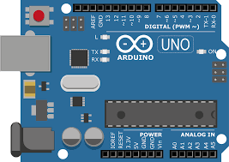

Fig 1: Arduino Uno microcontroller

* **Digital pins** The digital pin section is pinned no 0 to 13 in which 6 pins are capable to take or through analog signals, these pins are known as PWM (pulse width modulation) pins. In this section, pin no 0 and 1 are the Rx and Tx pins where Rx stands for receiver and Tx is for Transmitter pin.
* **Analog pins** In this pin section, there are 6 analog pins available for analog signal purposes. This signal can be in the Output form or Input form. There are lots of analog sensors available in the IoT world.

* **Power Pins** In this section. Here are two ground pins, which are used as the negative terminal for the LED and other sensors, one 5V pin, one 3.3V pin for the power supply.
  + 1. **Raspberry Pi Microcontrollers**

Raspberry pi is also a microcontroller device that is used to perform multiple computational tasks in the IoT world. It is firstly developed in the UK by Raspberry Pi foundation and Broadcom co. It is used to learn new technologies, make new projects, and develop new solutions for IoT devices. The release date of Raspberry pi is 24 February 2012. It is available in many variants; all the variants depend on the chip on it and the RAM of the board. It is a very powerful microcontroller board due to its processing and RAM. The Raspberry Pi 4 has Broadcom BCM2711 with a 64-bit quad-core ARM-Cortex-A72 processor and the clock speed is 1.5 GHz.

Raspberry Pi has a unique feature that is its communication system with other devices. It has an Ethernet port for communication to other devices and it is auto-sensing. The meaning of autosensing here is that we can connect the Ethernet port directly to the router as well as another PC. We don’t need to do any type of configuration for it [9]. As we all know that the size does matter in the IoT world. Our prototype is effective and more reliable as much as it is compact in size as well as cost too. The main reason to choose this microcontroller is, it has a more powerful CPU which is also cost-effective and can be done multiple tasks easily. It is also more reliable in the form of energy consumption [4].

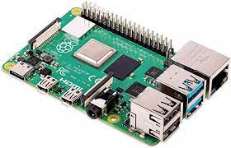

Fig 2: Raspberry Pi Microcontroller

In the above figure, this is the Raspberry Pi Modal 4 B with 8 GB RAM single board and also suitable for mini-PC, smart Robots, etc. It has inbuilt Bluetooth v5 connectivity. It has 26 pins, in each row, there are 13 pins for general input and output.

**2.2 UTHM College Bus Tracker by Broadcasting**

By using the IoT (Internet of Things), GPS (Global Positioning System), Arduino UNO they have made a system in which we can check the real-time location of buses. To view the broadcast of the location they have used ManyCam, Google+ Hangouts, and YouTube as well as Facebook. There was a problem for students who lives inside or outside of college for checking bus locations. To solve this issue, their system has provided some benefits/advantages for students. Students will be able to check the exact location on some broadcast systems of buses to save their time [5].

**2.3 Vehicle Location Tracker for Facilities Manager**

A GPS-based tracking system was designed by S. Madhuri & their team from VBIT (Vignana Bharathi Institute of Technology) [6], in which the location of the vehicle can be checked by using Arduino, MATLAB, Google Maps API. In this, they focused on the facilities manager to monitor the route of vehicles being used for transport. They will be able to see the traversed path of any vehicle. By using this, the military will be able to check which vehicle is used for the mission to track.

**2.4 GPS System using NodeMCU & Neo 6m GPS Module**

A Location finder system was developed by Preety Singh from Government Engineering College by using GPS technology, Neo 6m GPS module, and NodeMCU. In this, people can track the location of their vehicle. There was a problem for people who park their vehicle & unable to find it. They focused on this problem to make a system in which people can track the location [7].

Fig 3: Ublox Neo 6M GPS Module.

**2.5 GPS using AWS/Microsoft Azure**

A team from Maharshi Dayanand University [8] have made an IOT based application in which they have tried to solve the problem of lost/stolen vehicle or bag. In this, they have used Google Map, Web Portal, Microsoft Azure/AWS which will show the real-time location of the vehicle on their android phones. In the future, they are trying to make an accelerometer that will be added to the tracking system in Airline Travel Sector.

**2.6 Driver’s Health Monitoring**

Other than the vehicle monitoring system, the monitoring of driver’s activity is also important. To do this, there are several ways to check the health and other activity of the driver, are available but one of the main, efficient, easy use as well as popular ways are IoT based health monitoring system. There are some major issues with the drivers which can be very dangerous while they are driving a vehicle like; consumption of alcohol, sleeping problems, distractions, and other health-related issues.

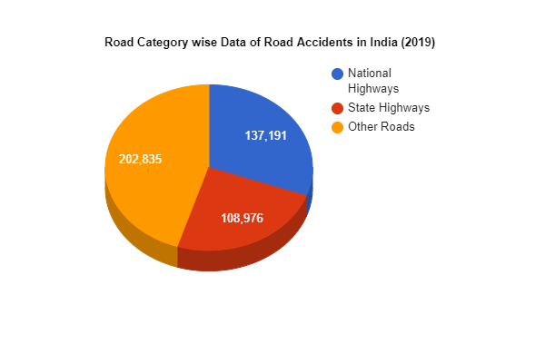

Fig 4: Road Accidents (2019)

The automobile industries are continuously trying to implement such systems to make their vehicles better and more securable. But something is missing yet. In the IoT-based driver health monitoring system, you need to get data about heart rate, body temperature, and the alcohol level of the driver. The MEMS (micro-electromechanical systems) technology and wireless sensor technologies are giving major support in the field of IoT-based monitoring systems. It is assumed that 50 billion IoT systems are going to be implemented by 2020 [9]. For driver monitoring systems, there are lots of medical sensors available in the market to implement and collect the data related to the human body like; Blood pressure, Body temperature, and breathing, etc [9]. Majorly medical sensors are wearable but, in some cases, we can use these sensors by connecting them directly to the microcontroller boards and another type of computational devices.

In this health monitoring prototype, data security is one of the major challenges [9],to fix this vulnerability one other system is proposed with the use of blockchain technology in IoT. By using blockchain technology we can secure the sensors generated data [10].

**2.7 Alcohol Detection**

Consumption of alcohol while driving is one of the main reasons for accidents all over the world. It is not only dangerous for the driver but passengers too. As we already showed the figures related to the accidents due to the alcohol consumption in India as well as all over the world, we need to implement a solid system which gives the alert when any driver of any school, college, or any other type of organizational as well as personal vehicle consume alcohol. To avoid these types of accidents, we need to implement an IoT-based health monitoring system (as described earlier) with an alcohol detector. M.H Mohammad and their team [11] are proposed a solution for this. They give us an alcohol detector system that is completely based on IoT. In this, they have used the MQ-3 alcohol gas sensor [11] to detect the concentration of alcoholic elements near the steering.

Fig 5: MQ-3 Alcohol sensor

In the given figure, It is an alcohol gas sensor. The modal MQ-3 is a very powerful alcohol sensor for IoT automation. It is a very cost-effective, reliable, and compact electronic sensor. It can be easily connected to any microcontroller device. It has 4 I/O pins, in which Vcc is for power supply, GND is for ground connection, DOUT is to get the data from it in digital form, and AOUT is for analog signals. So, this sensor can send the data to the microcontroller device digitally as well as analog.

Gabriel Gasparesc [12] also proposed an IoT-based solution to avoid the consumption of alcohol at the time of driving. In this, he used the microcontroller boards, alcohol sensor, LCD to display something. According to this system, if the driver drinks and tries to drive the vehicle then the ignition system is turned off automatically [12]. This is system is much better but what about the organization inquiry? For this, we should need to establish a control panel, at which the real-time information of the driver’s body is displayed.

**2.8 Pulse & Temperature Detection**

Majorly used sensors for measuring the temp are the LM-35 temperature sensor and the pulse sensor to monitor the heart rate by connecting it to the Arduino microcontroller. In this article, she got the heart rate rating in BPM [beat per minute]. From the driver’s monitoring point of view, this is also very helpful because as we discussed earlier that we need to get the alcohol consumption-related data onto an admin panel, so the temperature-related and pulse-related data can be delivered to the same admin panel. By doing this we can get more data about the driver’s physical body information.

According to Yuda Irawan [13], a medical check-up is important in our day-to-day life. Firstly, the doctors check the heart rate in kind of medical disease because it is important to know about our heart that it is working will satisfying condition or not. Irawan [13] showed an experimental setup in their paper to measure the heart rate by using just an Arduino microcontroller board and a pulse sensor. His team is successfully able to receive the data on the android platform.

**2.9 IR Sensor**

IR sensors can sense the Infrared spectrum that’s why it is called IR sensor. In the Electromagnetic spectrum, the IR spectrum is furthermore divided into three sub-regions which are near-infrared, infrared, and far-infrared regions. An IR sensor uses these spectrums to detect the heat of a body and the motion of a body. These infrared signals are unable to detect by the human eyes. In the IoT world, the IR sensor is a very useful sensor to collect the data about Heat as well as the motion of a body because we have lots of operations to automate in which we use to detect the motion of the body and heat of the body.

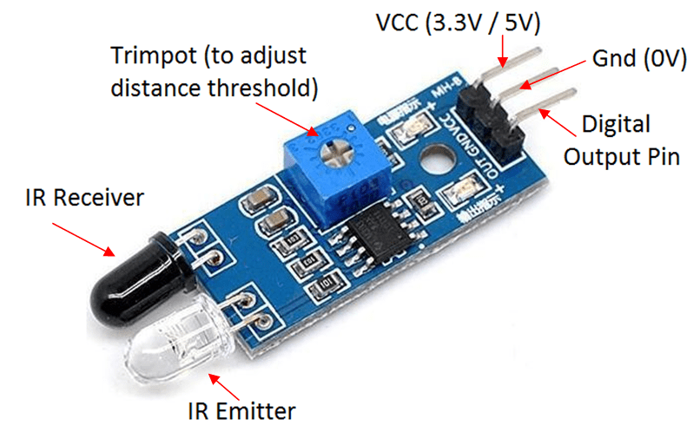In the given figure, has one emitter led and one receiver Photodiode? The working of the IR sensor.

Fig 6: IR Sensor.

is very simple. Firstly, the emitter LED is used to send the signals towards the sensor, so the IR beam is emitted by the LED. If any object crosses this beam (which is an IR beam and is unable to be detected by human eyes) then the IR beam is reflected by the object and here the working of the photodiode starts. Now the photodiode receives this IR beam and gives the signal to the microcontroller device that something in the way or something crosses the path of the IR beam that means any movement occurs in the range of the IR sensor.

In this sensor module, there are three different pins available. In these pins, one pin is Vcc to give the power supply to the sensor module. In general, a +3.3 or +5V power supply is used for operating the sensor. The second pin in the sensor is GND and it is connected to the ground terminal of the battery directly. In the last we have DOUT pin, this pin is used to give the signals to the microcontroller devices in the form of digital signals.

**2.10 Ethernet shield**

The Ethernet shield is used to provide Internet access to the given microcontroller devices. An Arduino Ethernet shield is a circuit that has an Ethernet port and power source ports. The shield can be easily fixed on the Arduino boards. For using this we don’t need to solder anything, we just take the shield and merge it on the top of the Arduino board [14].

In general, this type of Ethernet shield is working on the Wiznet W5100 ethernet chip and it also has both TCP and UDP packet transmission. An SD card also can be used with the Ethernet shield for storage purposes. The operating voltage for the shield is a 5v DC power supply and it is capable to achieve the data transmission speed up to 100mbps [14].

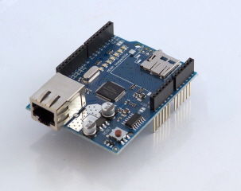

Fig 7: Arduino Ethernet shield.

In the given figure, has a LAN Ethernet connection port and has an equal no of pins of Arduino board. It has a 16 MHz crystal oscillator and a reset button also.

**2.11 Humidity Sensors**

Before we start with the humidity sensor, we need to understand that what is Humidity? so humidity is the presence of water vapours in the atmosphere. We know very well that water has three states i.e., solid, liquid, and gas. The water vapours are available in the air are known as the humidity and we also have a sensor to measure the humidity of the air.

Humidity sensors are very useful electronic devices. It gives the output signals digitally as well as in analog form. It is used at various places and some major places are the medical sector, automobile sector, and manufacturing industries. The size of these sensors can vary along with their uses. By the process of calculation of humidity in the atmosphere the humidity sensor is divided into two main groups, first is RH (relative humidity) and the second is AH (absolute Humidity). In the first type of Humidity sensors, the calculation of humidity is based on temperature, and it is the main factor for this but in the AH sensor’s calculation, Humidity is measured without depending on temperature.

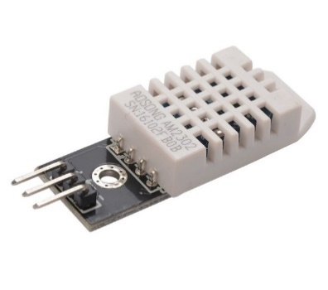Suraj Kaushik [15] and their entire team is used a DHT22 humidity sensor to find out the humidity of a room. They also connect some specific tasks with the sensor and can get an automatic fan speed controller by varying the humidity and the temperature of any room. DHT22 is a very useful humidity sensor for general purposes as well as home automation. In this project, they can achieve the different-different speed at different humidity. DHT22 sensor not only senses the level of humidity but can measure the temperature of the atmosphere also. The only drawback of this sensor is that it can give data related to humidity in the gap of every 2 seconds. This sensor can be easily connected with any type of microcontroller device.

Fig 8: DHT22 Humidity Sensor

It has three connecting pins namely, Vcc, GND, DATA output pin. Vcc is used to give the main power supply to the sensor. In general, it is between +3V to +5V DC voltage. GND is connected to the ground connection directly and the data output pin is used to give the temperature readings as well as humidity readings to the microcontrollers board. The maximum operating current for this sensor is near about 2.5 mA and the humidity range is 0-100%/2-5%.

**2.12 Gyroscope sensor**

Gyroscope sensors are very useful in IoT applications as well as the Robotics application. A gyro sensor senses the difference in angular velocity, so it is also known as an angular sensor. There are lots of applications are available around us, which is using the Gyroscope and working on it, for example, car navigation systems, DSLR cameras, radio-controlled helicopters, aircraft as well as smartphones also have a tiny Gyroscope in it.

One most popular gyro sensors is the L3G4200D sensor. It is majorly used in UAVs, Robotics, and 3D motion controlling systems. This gyro module has 3-Axis angular ratings for yaw, pitch, and roll. It is easy to use, compact in design, reliable as well as works at low power consumption. It can be easily used in aircraft navigation systems and supports two types of communication I2C and SPI systems.

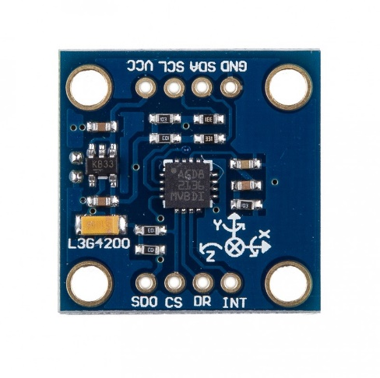

Fig 9: L3G4200D Gyroscope Sensor

It has a 16-bit rate value for data output and required operating voltage between +2.5V to +6.5V DC. The current usage is near about 7mA at 5V DC voltages.

Another popular gyro sensor is MPU6050. Ibnu Rifajar and his team [16] is used this sensor for making a path direction auto controllable robot. This robot is a dancing self-walking robot. They used many gyros sensors in this project to achieve 100% results.

The main thing before we use any gyro sensor is the configuration and calibration. In their project, they described the calibration of MPU6050 calibration well. The clockwise rotation of the sensor is the Z-axis (yaw), at this rotation the voltage output decreases. If we need to calibrate this sensor, we need to find its offset value function and offset angle [16].

It is not only for measuring the angular change rate or gyro, but it is also used to detect the temperature as well as the acceleration of the object.

Ehsan Qahtan Ahmed and the team [17] used this MPU6050 sensor module for the two-wheel balancing system. In this system, they used an Arduino microcontroller board, An ultrasonic sensor, a Motor driver, and two motors. They also calibrate first the sensor module and set some parameters in it assuming the initial state of the sensor. They can achieve positive results through this module. This sensor module is very reliable, cost-effective, easy to use.

**2.13 Node MCU ESP8266 Wi-Fi Module**

As we discussed earlier that IoT is the network of physical things. Things can be anything, like an electronic device, Electrical device, or Mechanical system. The Ethernet shields are used to connect the IoT components with the help of a LAN cable but instead of physical connections, we have lots of electronic devices to provide the internet for the IoT microcontrollers with the help of Wi-Fi connectivity. In the IoT automation world, one of the popular Wi-Fi modules is the Node MCU ESP8266 module [18]. ESP is the manufacturer of this module, and its ESP stands for Espressif Systems.

This module can easily connect to any Microcontroller device like Arduino or raspberry pi etc, In this Module, there are 13 general I/O pins one Vcc, One Ground, and other helping pins [18]. The operating voltage is between +3.3-volt Direct Current.

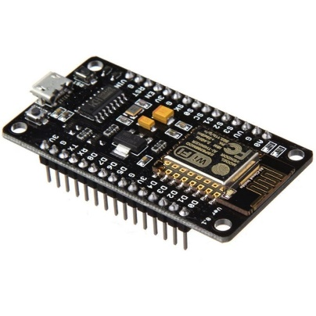

Fig 10: Node MCU ESP8266 Wi-Fi Module

This module has built-in 4 MB flash memory that makes this module more powerful. It is based on the Tensilica Xtensa LX106 core and it is very useful in IoT applications or projects.

**2.14 Laser Projection System**

After core laser light show projectors take one or more laser diode to send that beam to some optical path to create a field in the air or on the wall at their core laser light show projector take one or more laser diodes and send that beam through some optical path to create a beam in the air or on the wall [19]. You can even make your laser projector based on the same principles using a few moving mirrors. These mirrors are mounted on tiny high-speed precision motors called galvanometers; these galvanometers move this single beam through space quickly enough that to the eye. Their main function is to interpret the from your lighting console or computer into something the laser diodes and scanners can use to create patterns in this next section.

As a laser diode module, this projector is the most common configuration of red, green, and blue. While others reflect allowing us to combine multiple laser diodes into a single beam path this single beam path then goes to set off what most people need a street call Calvo’s, or a Galvo set Gallo’s are a set of galvanometer motors and a block with high-efficiency mirrors mounted on their shafts in this configuration the laser beam hits the lower mirror first which then control the X-axis movement of the output. If we had a sine wave to the Y-axis, then this is times sine wave on the X-axis, but it had 90 degrees offset. Which is making across the circle the circles being drawn in an array of once per second or 1 Hertz. The same principles applied column regulation the most commonly used control signal for laser diode drivers is zero to 5 volts per color for zero to 100% power for each color. If we then drop the green voltage to zero. The laser goes through the middle of the X-axis and prints.

1. **COMPARISON TABLE**

Table 1: Comparison Table of Different Existing Systems & our Module.

1. **PROBLEM STATEMENT**

As we know that nearly 1.3 million people die each year in the world in road traffic accidents. This figure is very large in terms of death. In the given figure, many of them are the only person who was earning in their family and due to this not only one person dies but also their family will not be able to survive. In India, 1,33,201 people died due to road accidents during 2020. More than 3.54 lakh road accidents happened in India and approx. 60% of cases were due to overspeeding. If we talk about the percentage of death rate in India from the given of 1.3 million by W.H.O is 10% of 1.3 million. According to National Crime Record Bureau (NCRB), the drink & drive road accidents that occurred in 2019 were 12,256 and this figure is the registered cases & the unregistered cases can be a huge figure. Around 2% of overall road accidents are due to drinking and drive. By the Times of India’s article, “Approx. 10,007 road accidents occurred due to fog out of which 7205 people lost their lives in 2019”.

Many of the injured people due to the road accidents also lose their life as if accidents happened, there were not many people to help them and also, we can’t track their location to send them to the medical facility. Many of the people’s lives can be saved if we know their exact location. Due to these accidents only not, the driver lost their life but also many innocent people die. If we talk about the buses a mistake by a driver can risk all the life of passengers. A small mistake can risk the lives of innocent people. If we analyze the factor of accidents, then the major factor is overspeeding drink and drive and weather conditions. To reduce these accidents, we are establishing a system in which the figure of road accidents due to over speeding drink and drive foggy weather and the bad health of drivers can be reduced and also to get the exact location of accidents that happened so that we can send them medical facilities instantly.

1. **FUTURE OUTCOME**

As we all know, road traffic accidents are increasing day by day. nearly 1.3 million people die each year in the world in road traffic accidents. In India, 1,33,201 people died due to road accidents during 2020. More than 3.54 lakh road accidents happened in India and approx. 60% of cases were due to overspeeding. If we talk about the percentage of death rate in India from the given of 1.3 million by W.H.O is 10% of 1.3 million. Many people’s lives can be saved by knowing their accidental location. [Problem Statement] If we analyze the factor of accidents, then the major factor is overspeeding drink and drive and weather conditions. To reduce these accidents, we are establishing a system in which the figure of road accidents due to over speeding drink and drive foggy weather and the bad health of drivers can be reduced and also to get the exact location of accidents that happened so that we can send them medical facilities instantly. [Problem Statement] We have to make a system in which we can control the number of accidents occurring day by day.

By using the Arduino UNO Microcontroller, Ublox Neo 6m GPS Module, SIM800L GSM Module, ESP8366 Wi-Fi Module, Pulse Sensor, LM-35 Temperature Sensor, MQ-3 Sensor, Web Server, Google Map API, and Laser, we can develop an IoT based Architecture in which we can monitor the alcohol level, pulse level, temperature of driver and exact location of the vehicle also we can reduce the accidental risks due to bad health of driver or alcohol consumption of driver.

We can decrease the road accidents of vehicles in foggy weather by making a Laser-Based System. By monitoring the health of the driver, we can reduce the number of accidents that happen in today’s world. Also, we can save the lives of innocent people who die in accidents and save their life by tracking the location of the vehicle where the accident happened to send them medical facility instantly

1. **RESULT**

As of now we have many technologies till date. By using Arduino UNO and connecting it with Ublox Neo 6m, SIM 800L GSM Module, and after creating a web server & a database where the GPS data will be stored & connecting it Google API Key, we can get the location the exact location vehicle on the web server. To check the health of drivers, we will use pulse sensor, LM35 temperature sensor, by fixing it in the steering of vehicle & MQ-3 Alcohol Gas Sensor in seat belt to check the alcohol level and connecting the sensors with Arduino UNO to send the measurements on server. To reduce the accidents in foggy weather, we will deploy a Laser System on the back top of vehicle. In case the speed of vehicle is reduced to provided limit, the laser system will show provided words on the road (i.e. Stop/ Vehicle Ahead) in the range of 20 meters.

1. **CONCLUSION**

As we all know the number of road traffic accidents is increasing day by day. An accident not only harms one individual but the whole family, society, as well as country, can be disturbed by this. Most of the road traffic accidents happens due to the driver’s mistake (over speeding, influence of alcohol, his bad health) and foggy weather. A small mistake of driver can risk the passengers’ lives. To reduce the number of cases, we need to implement a system in which the cases will shrink. By using IoT applications, we can develop a system in which the driver's health, vehicle location can be monitored remotely. On the other hand, by developing a system based on laser we can decrease the number of road traffic accidents in foggy weather.

**ACKNOWLEDGEMENT**

The authors would like to thank everyone for all the guidance.

**REFERENCES**

[1] In Lee, Kyoochun Lee, “The Internet of Things (IoT): Applications, investments, and challenges for enterprises”, School of CS, Western Illinois university U.S.A. published by Elsevier.

[2] Alan G. Smith, “Introduction to Arduino (Book)”, CreateSpace Independent Publishing Platform (19 August 2011).

[3] Jovan Ivković, Jelena Lužija Ivković, Analysis of the Performance of the New Generation of 32-bit Microcontrollers for IoT and Big Data Application from ITS Visoka škola strukovnih studija za IT/ information technologies, Belgrade, Serbia and MyITLab, Belgrade, Serbia.

[4] Mohannad Ibrahim; Abdelghafor Elgamri; Sharief Babiker; Ahmed Mohamed” Internet of things based smart environmental monitoring using the Raspberry-Pi computer” 2015 Fifth International Conference on Digital Information Processing and Communications (ICDIPC).

[5] Mohammad Y. M. Ibrahim, and Lukman Audah, “Real-time bus location monitoring using Arduino”, Published by the American Institute of Physics.

[6] S. Madhuri, K. Bhuvana Jyothi, Ch. Indraja, “GPS based Passive Vehicle Tracking Using Arduino” published at researchgate.net

[7] Pretty Singh, “Real-Time Vehicle Location Finder”, International journal of advance research in computer and communication engineering.

[8] Dheer Dhwaz Barak1, Khushwant Singh2, Prashant Ahlawat3, Hitesh Kumar Sharma4 1Dept. Of CSE GITAM, 2 Maharshi Dayanand University Rohtak, 3Dept. Of CSE GITAM, 4 School of Computer Science, University of Petroleum and Energy Studies.

[9] Pawan Singh, “INTERNET OF THINGS BASED HEALTH MONITORING SYSTEM: OPPORTUNITIES AND CHALLENGES”, International journal of advance research in computer science volume 9, no. 1 January-February 2018.

[10] Ana Reyna, Cristian Martín, Jaime Chen, Enrique Soler, Manuel Díaz, On blockchain and its integration with IoT. Challenges and opportunities, from Department of Languages and Computer Science, University of Málaga, Boulevar Louis Pasteur 35, 29071 Málaga, Spain.

[11] M.H Mohamad, Mohd Amin Bin Hasanuddin, Mohd Hafizzie Bin Ramli, “Vehicle Accident Prevention System Embedded with Alcohol Detector”, International Journal of Review in Electronics & Communication Engineering (IJRESE) vol. 1 04/Oct/2013.

[12] Gabriel Gasparsec, “Driver Alcohol Detection System Based on Virtual Instrumentation”, published at IFAC online.

[13] Yuda Irawan, Yunior Fernando, Refni Wahuni, “Detecting Heart Rate using Pulse sensor as alternative knowing Heart condition”, Journal of Applied Engineering and Technology Science (JAETS) vol.1 no.1 2019.

[14] Anand Nayyar; Vikram Puri “A review of Arduino board's, Lilypad's & Arduino shields”, 2016 3rd International Conference on Computing for Sustainable Global Development (INDIACom).

[15] Suraj Kaushik, Nagendra Sharma, Yuvraj Singh Chouhan, Shreyansh Singh, P Suganya, “Automatic Fan Speed Control using Temperature and Humidity Sensor and Arduino” International Journal of Advance Research, Ideas and Innovations In Technology, vol.4 2018.

[16] Ibnu Rifajar, Abdul Fadlil, “The Path Direction Control System for Language Jagad Dance Robot Using the MPU6050 Gyroscope Sensor”, International Journal of Robotics and Control 27 Vol. 1, No. 1, March 2021, pp. 27-40.

[17] Ehsan Qahtan Ahmed, Ibtisam A.Aljazaery, Azhar F. Al-zubidi, and Haider TH. Salim AlRikabi, “Design and implementation control system for a self-balancing robot based on internet of things by using Arduino microcontroller”, Periodicals of Engineering and Natural Science (PEN) vol. 9, No. 3, July 2021, pp.409-417.

[18] F W Wibowo “Wireless Communication Design of Internet of Thing based on FGPA and Wi-Fi Module”, Journal of Physics: Conference Series 2nd ICERA 1577(2020) 012035 DOI: 10.1088/1742-6596/1577/1/01035

[19] Suman Singha, Debasis Maji, “LASER SECURITY SYSTEM”, International Journal of Scientific & Engineering Research, Volume 7, Issue 4, April-2016 214 ISSN 2229-5518

[20] Pratiksha Bhuta, Karan Desai, Archita Keni, “Alcohol Detection and Vehicle Controlling”, International Journal of Engineering Trends and Applications (IJETA) – Volume 2 Issue 2, Mar-Apr 2015.

[21] Boddapati Venkata sai Padmaja, Venkata Ratnam Kolluru, Syam Sai Kota, “IoT based Implementation of Vehicle Monitoring and Tracking system using Node MCU”, International Journal of Innovative Technology and Exploring Engineering (IJITEE) ISSN: 2278-3075, Volume-8 Issue-6, April 2019.

**AUTHORS**

Ms. Richa Saxena

Mohd. Suhail is a student of B.Tech 2nd year in the department of CS&E, Moradabad Institute of Technology. He did his schooling at J.L.M. Inter College, Sirsi. His major working field is IoT. He achieved the first position for the project named Automatic Railway Crossing System in District Science Club, Sambhal, Uttar Pradesh.

Email-ID - [mohdsuhail2232@gmail.com](mailto:mohdsuhail2232@gmail.com)

Mr. Aman Ruhela is a student of B.Tech 2nd year in the department of CS&E, Moradabad Institute of Technology. He did his schooling at Chitragupt Inter College, Moradabad. He is an Android Development Enthusiast. He developed an Android Application named LastYear AKTU in a team.

Email-ID - [amanruhela36@gmail.com](mailto:amanruhela36@gmail.com)

Mr. Himanshu Singh is a student of B.Tech 2nd year in the department of CS&E, Moradabad Institute of Technology. He did his schooling at Radha Krishna Inter College, Sambhal. He developed a Rover Project in a team.

Email-ID - [himanshuwch@gmail.com](mailto:himanshuwch@gmail.com)